

Project Proposal

<Website for a Musician/Band>

<Group 8>

<TheBlackHoods 6 – TBH6 (Musician/Band)>

<Dr. Mansoor Ebrahim>

<https://github.com/khizeratiq/Website-For-Music-Band.git>
Project Proposal

Section – 1

1.1 Project Identification
Project Title:
< TheBlackHoods 6 – TBH6 (Musician/Band)>

Group Leader (GL):
1. | Name: |  | Muhammad Khizer Atiq
 | Reg #: |  | 41374
 | CGPA: |  | 3.47
 | Mobile # : |  | 03492019828 |  | Email: |  |  |  | Khizeratiq1@gmail.com
 | Signature:
Group Members (GM’s):
2. | Name: |  | Muhammad Nouman Saleem
 | Reg #: |  | 41307
 | CGPA: |  | 3.64
 | Mobile # : |  | 0349 2182326 |  |  |  |  | Email: |  | noumansaleem1999@gmail.com
 | Signature:
3. | Name: |  | Javeria Salim
 | Reg #: |  | 42300
 | CGPA: |  | 3.24
 | Mobile # : |  | 0340 8383718 |  |  |  |  | Email: |  | javeriasalim4@gmail.com
 | Signature:
4. | Name: | Zaid Bin Hameed
 | Reg #: | 41086
 | CGPA: | 2.8
 | Mobile # : | 0306 2008686 | Email: | zaidhameed170606@gmail.com
 | Signature:

5. | Name: | Muhammad Ahmed
 | Reg #: | 41396
 | CGPA: | 2.89
 | Mobile # : | 0336 8940649 | Email: | ahmed.khatri.908@gmail.com
 | Signature:

What technology is core to your product? (Please mark ☑ where applicable)
[ ] 3D/4D Printing |  | [ ] Augmented Reality / Virtual Reality
[ ] Big Data, Artificial Intelligence |  | [ ] Blockchain
[ ] Cloud |  | [ ] Neurotech
[ ] Robotics |  | [ ] Shared economy
[ ] The Internet of Things |  | [ ] Wearables, Implantables
[☑] Others (specify): | Website for Musical Band known as The Black Hoods

What is the target market(s) for the products? (Please mark ☑ where applicable)
[ ] Automotive, aviation, marine |  | [ ] Business, marketing, finance
[ ] Defence, security, safety |  | [ ] Education and training
[ ] Environment, water management |  | [☑] Entertainment, tourism, sport/recreation
[ ] Food, livestock, agribusiness |  | [ ] Healthcare
[ ] Infrastructure, housing & transport |  | [ ] Mining equipment technology & services
[ ] Oil, gas, energy |  | [ ] Textiles, clothing, footwear
[ ] Others (specify):

Other Organizations Involved in the Project: (Please identify all affiliated organizations collaborating in the project, and describe their role/contribution to the project.)
Academic Organizations:
# |  | Organization Name |  |  |  |  | Role / Contribution
 |  | Iqra University |  |  |  |  | Educational Institute
Industrial Organizations:
# |  | Organization Name |  |  |  | Role / Contribution
Funding Organizations:
# |  | Organization Name |  |  |  |  | Role / Contribution
 |  | The Black Hoods |  |  |  |  | They are the client who wants us to make their website
Key Words: (Please provide a maximum of 5 key words that describe the project)
<Musician, Singer, Band, Event, Entertainment>

Project Status: (Please mark ☑)
[☑] New [ ] Modification to previous Project
[ ] Extension of existing project

Project Duration: |  |  |  | 1 Month
Proposed Budget: |  |  |  | 2000 - PKR
Project Description (what you want to do)
(Provide a simple, high-level description of the project that clearly states the overall business goal of the initiative. If the description is highly technical or utilizes acronyms, please provide a one paragraph summary in layman’s terms of the project.)
< We will make a website for a musical band called The Black Hoods which is newly formed musical band of some energetic youngsters. These youngsters want more public attention as they are in the initial state of developing a successful band. So this portfolio will help them to get the attention they want. >nnnnnnnnnnnnnnnnnnnnnnnnnnnnnnnnnnnnnnnnnnnnnnnnnnnnnnnnnnnnnnnnnnnnnnnnnnnnnnnnnnnnnnnnnnnnnnnnnn

Project Justification (why you want to do this)
(A simple, high-level description of the benefits the project will achieve (generally a paragraph or less).
< To help the musical band called Black Hoods to get public attention they want to reach their goal. This will help to pop-up the name of Black Hoods to the top searches so they can be found easily. >

We will use the following techniques/tools to achieve the final product.
(Maximum 200 words.)
<
- We will develop the website for the portfolio on ASP.net.
- For which we will work on visual studio 2019 community.
- We will create database if required for this project.
- CSS will be used to style the website.
- Bootstrap will be used to make website responsive.
- Then we will create a repository link on GitHub and post the material as our work goes on.
- We will also use GitHub as a host of our website.
>

Synopsis:
(A brief description of the idea, in non-technical language, explaining product benefit, target market, basic technology, commercial partners, investors, and potential customers. Maximum 200 words.)
<The idea is to create a portfolio such that it reflects every aspect of their lifestyle ,their work, their passion for music so when a viewer sees their portfolio he/she immediately understands what their work is and what they are doing. This band is a newly established band so we will try to keep their portfolio as simple as possible as per their requirement. For this purpose we won’t be using any high-level language to develop this portfolio. There won’t be any partners and sponsors because they are not well-know by now. We will also create dummy steps so that in future they can easily edit or update their content according to their need and growth>

Section – 2

2.1 Background
Scope of the Project:
< Our main focus is to build a portfolio for the band which will get them enough attention to make their ground in the market >

Challenges: (Please describe the challenges, specific to this research topic, currently being faced internationally. Maximum 500 words.)
<Here the challenges are to make a portfolio which will make this band more popular ,to make it in such a way that it affects the viewer who are interested in this type of music and to compete with the music bands of same type and to develop its personal relations with other clients>

Motivation and Need: (Please describe the motivation and need for this work. Maximum 500 words.)
<There are many developers out there to make any possible website like this but our motivation is that we want this portfolio as simple as possible and attractive at the same time.
And the need for this portfolio is because The Black Hoods want more public attention>

2.2 Outcomes and Benefits
Expected Outcomes: (Provide a list of proposed project outputs including publications, databases etc.)
<
By the completion of this project we will have:
- A portfolio of the band called The black Hoods.
- Optimization to attract more viewers.
- Feedback and suggestions from user to improve our product.
>

Key Benefits and Beneficiaries: (Please identify clearly the benefits and potential customers/beneficiaries of the project.)
<
Benefits of this project will be:
- Will connect band members with their fans
- Help band to socialize easily

Beneficiaries of this project will be:
- Viewer can easily connect with the band
- Viewer can be updated about any future events

>

2.3 Objectives
(Please describe the measurable objectives of the project and define the expected results. Use results-oriented wording with verbs such as ‘to develop..’, ‘to implement..’, ‘to research..’, ‘to determine..‘, ‘to identify..’ The objectives should not be statements and should actually specify in simple words what the project team intends to achieve (something concrete and measurable/ deliverable). Fill only those objectives that are applicable to the proposed project.)
< We want to develop a website which will have a portfolio of the band called The Black Hoods 6 TBH 6. We will implement this project on visual studio. We will use this project to learn what viewers like when they visit this kind of website >

Key Milestones and Deliverables:
(Please list and describe the principal milestones and associated deliverables of the project. The timing of milestones is also to be shown in the Gantt chart in Annexure-A. Quarterly deliverables are preferred.)
S. No. | Elapsed time since start of the project | Milestone | Deliverable
1. | Week 01 |  | Project Proposal (Report)
2. | Week 02 |  | Feasibility study and Project Plan (Report)
3. | Week03 |  | Requirements
4. | Week04 |  | Design Document
5 | Week05 |  | Unit test scripts, test summaries
 | Week06 |  | Final delivery (Presentation & Documentation)
(Please add more rows if required.)

Section – 3

3.1 Resources & Other Requirements
Project Team:
The numbers in the table below must tally with the HR Cost sheet in the Budget file.
Title / Position | Number
Team Leads | 5
Researchers / Developers | 2
Researcher / Development Assistants | 2
Support Staff | 1
Contract Staff (please specify)
Others (please specify)
Add more rows if required
Team Structure:
(Please define the team structure (organogram) and role/key responsibilities of each member. If in collaboration with another partner, the division of manpower at various locations of partners be provided.)
Title/Position  (of each member) | Role/Key Responsibilities | Minimum Qualification Required | Expertise / Background Required | Minimum Experience Required (years)
Developer  (Muhammad Khizer Atiq) | To develop what is decided | HTML,CSS,  Bootstrap |  | -
Developer  (Muhammad Nouman Saleem) | To develop what is decided | HTML,CSS,  Bootstrap |  | -
Researcher  (Zaid Bin Hameed) | To do the research work for the project | System design |  | -
Researcher  (Javeria Salim) | To analyze the research submitted | System analysis and design |  | -
Researcher  (Muhammad Ahmed) | To run test on the research provided | System analysis |  | -

Client’s Requirement (Proof Document)

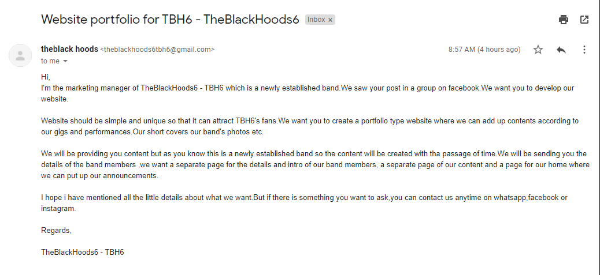

Remarks:

1. Name & Signature of client:

2. Name & Signature of Faculty:

